**Name: Noman Siddique**

**Roll Number: 19P1664**

**Subject: Software Design and Architecture**

**Lab Task: 13**

**Instructor: Usama Musharraf**

1. **No of Components:**
2. Doctor
3. hospital System
4. Patient
5. Nurse
6. Pharmacist/Chemist

**No of Components (sys) = 5**

**DESIGNING EACH COMPONENT**

***Doctor:***

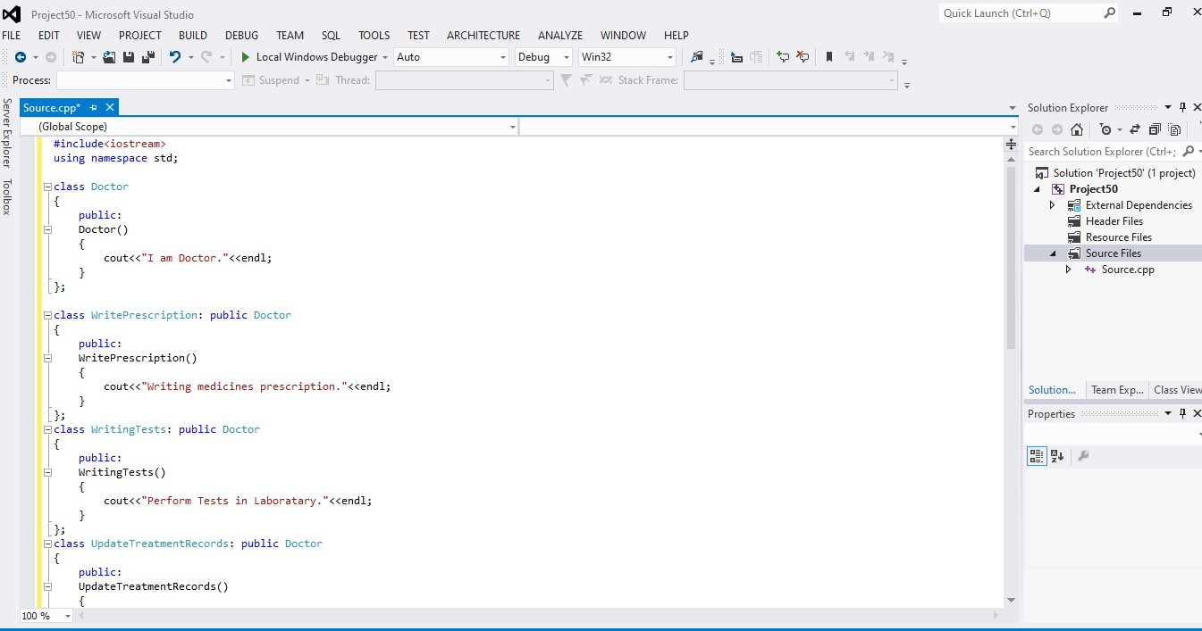

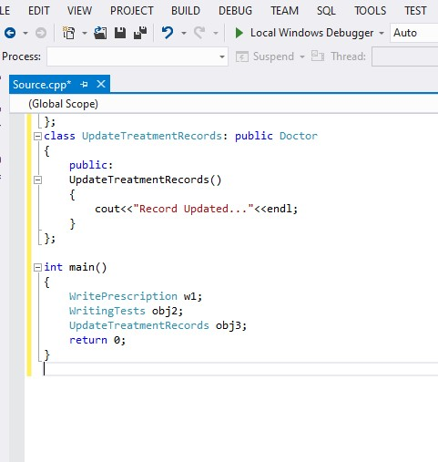

***Hospital system:***

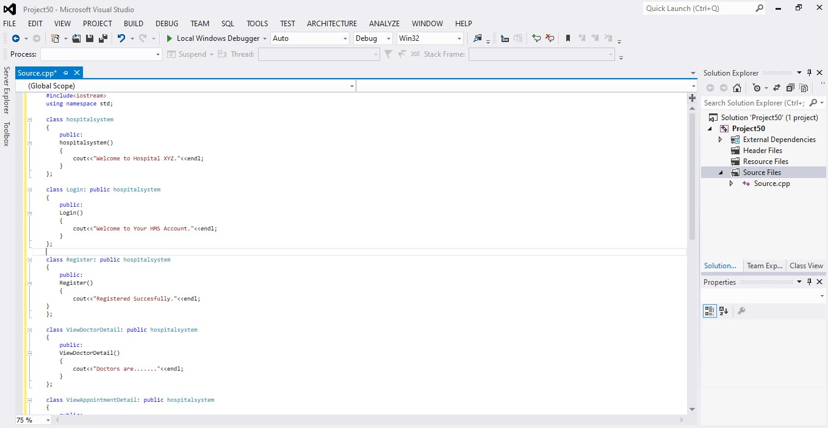

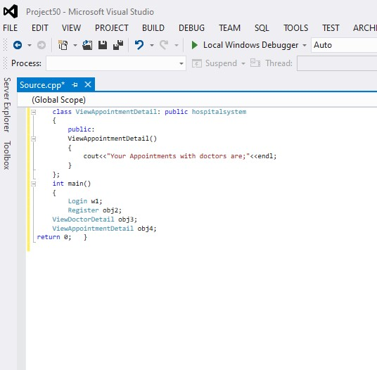

***Patient:***

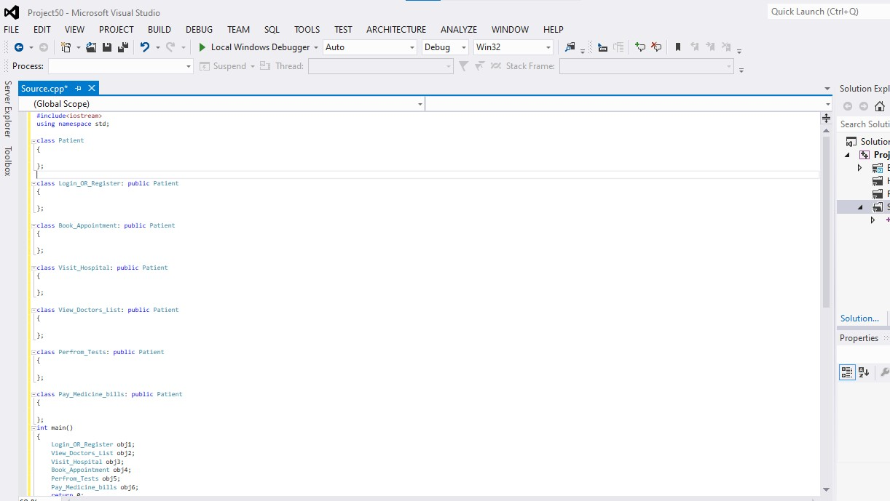

***Chemist/Pharmacist:***

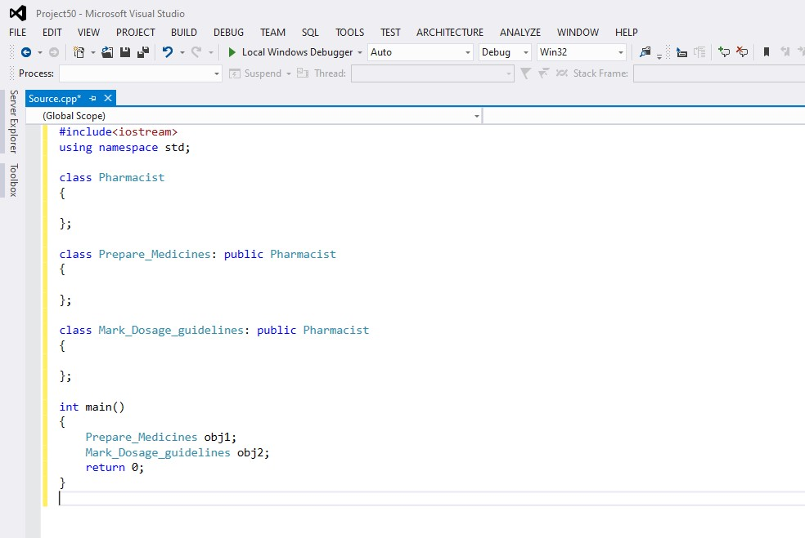

***Nurse:***

